Brasil Chapter Activities –

Talks on how Contextual Behavioral Therapies and RFT can contribute in the time of COVID-19 (2 editions)
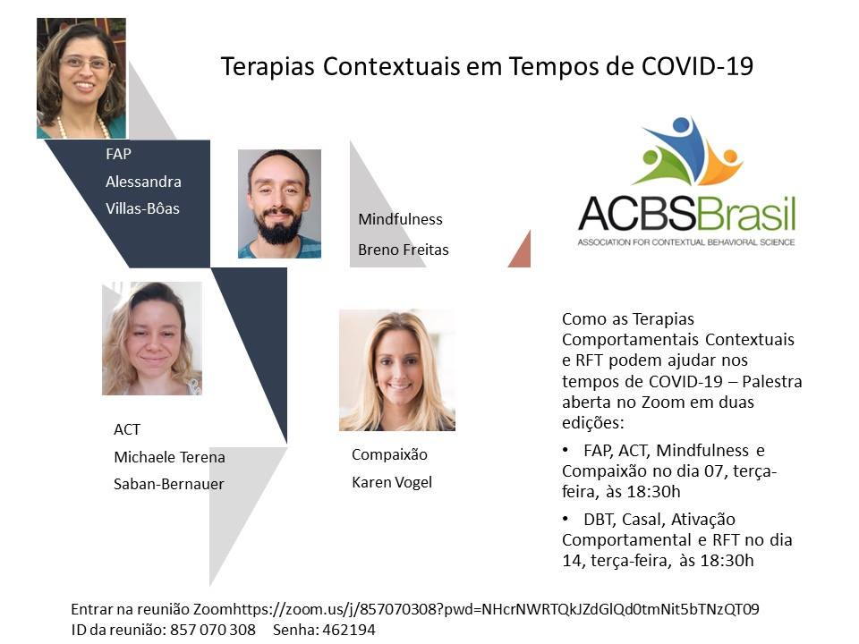
Recording for first edition here - https://www.youtube.com/watch?v=JAeTQrC3vtE&feature=youtu.be
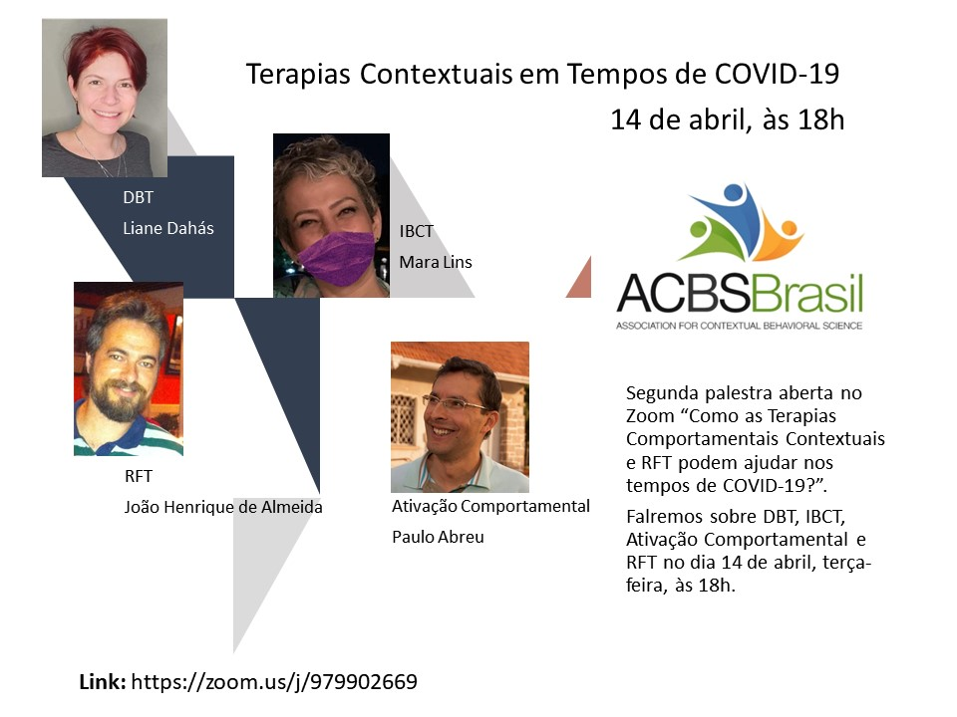
Recording for second edition here – ACBS Brasil em tempos de COVID 19- Segunda edição

2. On our website and social media, we are publishing free movements of lectures, mindfulness and texts to face the pandemic - https://www.facebook.com/pg/acbsbrasil/posts/?ref=page_internal

3. We are also publicizing institutions and organizations that need cash donations and supportive psychological care for the health front and vulnerable people
ACBS Brasil

Frente à crise do covid-19 a ACBS Brasil se propõe a divulgar diversas iniciativas da comunidade das ciências contextuais, e da psicologia de modo mais amplo, que se destinem a acolher/ ajudar/ informar membros da comunidade e público no geral, e também ações informando formas do público em ajudar outras pessoas, com trabalho, dinheiro etc.
Essas informações serão agrupadas neste álbum.
Se você souber de alguma iniciativa ou ação pertinente que pudermos divulgar, entre em contato conosco por inbox!
Alguns links interessantes:
Orientações do CFP: https://site.cfp.org.br/coronavirus/1-inicio/
Instituições de caridade: http://comoajudar.net/
Meditação de Autocompaixão com a Psicóloga Karen Vogel: https://youtu.be/IqmXA_Mc3VE
Sessões de Mindfulness, online, diárias e gratuitas, com Jon Kabat-Zinn, criador dos programas modernos de mindfulness: https://www.eventbrite.com/e/livestream-jon-kabat-zinn-cult…
Psicologia Solidária - Atendimento para profissionais de saúde ou brasileiros no exterior: link abre.ai/psicosolidaria-atendimento
4. The next project is a series of open classes on Contextual Science themes in which donation is encouraged to institutions that support people in vulnerability due to COVID-19 and help the health system.
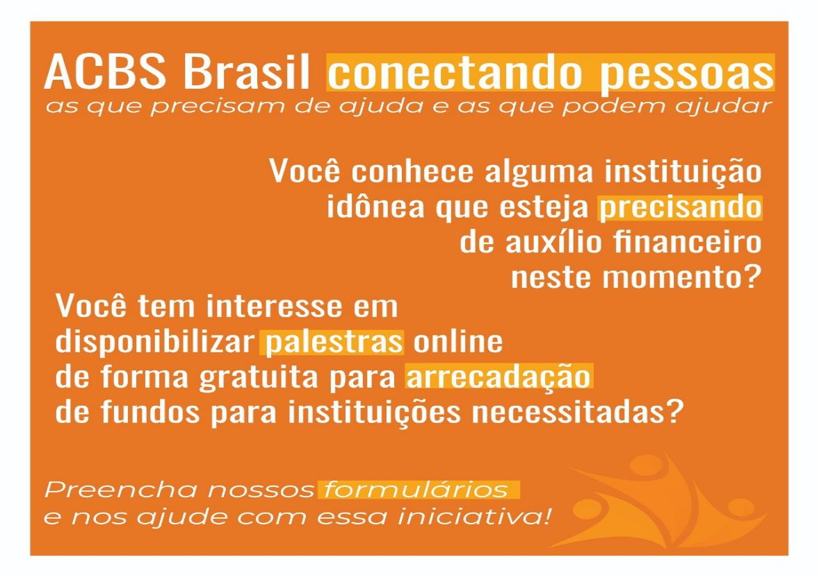
Given the period of social isolation in which we live, ACBS Brasil understands that there are institutions in need of help and also people with the possibility and desire to provide this assistance. In this sense, we plan an action to connect these institutions and people. You will find in this post two forms:
1 - To register institutions that need financial assistance due to the changes generated by Covid-19: https://forms.gle/xz5sKVZYg286yuHp7
2 - To register interested in offering lectures, workshops or events related to Contextual Behavioral Science, for psychologists or the lay population, in order to raise funds for donation to needy charities: https://forms.gle/MgquRmoqZCstW8cS7 Regarding the lectures, it is up to the speaker to organize the presentation form, the content , the date and duration of your talk, and your listeners will be invited to donate any amount of money to institutions in need.
Fill out the forms and be part of this initiative! Agenda of events already registered!
